# Exercises: HTML Forms and Styling Exercise and Homework

Problems for exercises and homework for the ["HTML and CSS" course @ SoftUni](https://softuni.bg/courses/web-fundamentals-html5). Submit your solutions in the SoftUni judge system at <https://judge.softuni.bg/Contests/410/HTML-Forms-and-Styling> .

## Search Job

Create a Web page (HTML5 + CSS3 + images) that looks and behaves like the screenshots below:

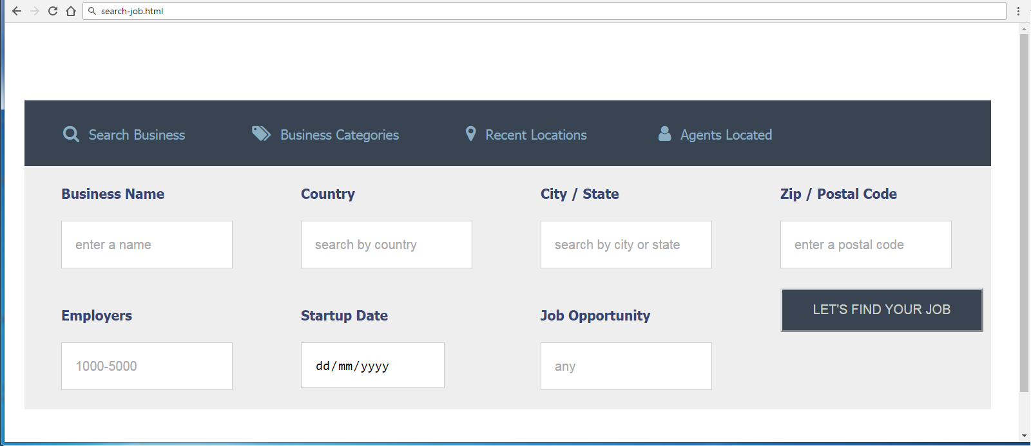

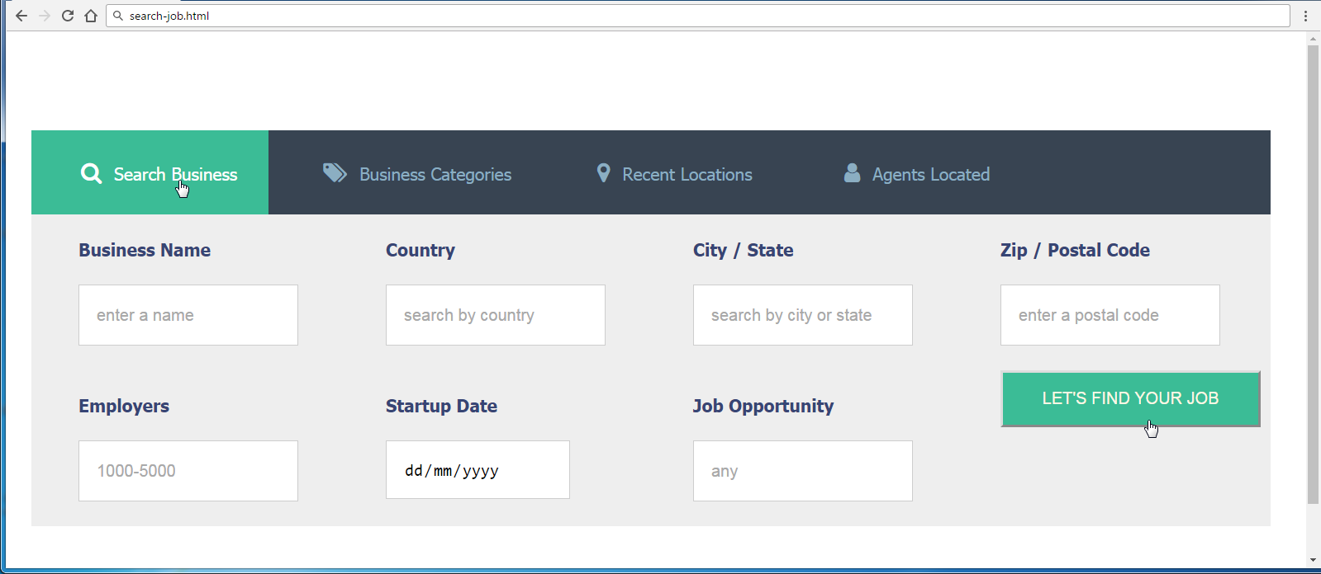

### Steps to Follow

Start with the **site header**:

* @import url('<https://cdnjs.cloudflare.com/ajax/libs/font-awesome/4.7.0/css/font-awesome.css>');
* <ul>, <div>, <nav>, <label>
  + Margin 0px;
  + Padding 0px;
* <body>
  + Text-size: 14px;
  + Font-Family: **Tahoma, Helvetica, sans-serif;**
  + Padding: **80px 50px;**
* <nav>
  + Width: 70%;
* Style the unordered list <ul> in the site navigation
  + Background-Color: #384452;
* Style the list items <li> in the site navigation
  + Display: **Inline Block**
  + Remove the bullets
  + Padding: 25px;
* Style hyperlinks
  + Remove the bullets
  + Margin Left: 15px;
  + Text Color: #8BAEC2;
* <a> before
  + Font Family**:** FontAwesome, serif;
  + Margin Right: 10px;
  + Font Size: 18px;

Test the site navigation in the browser:

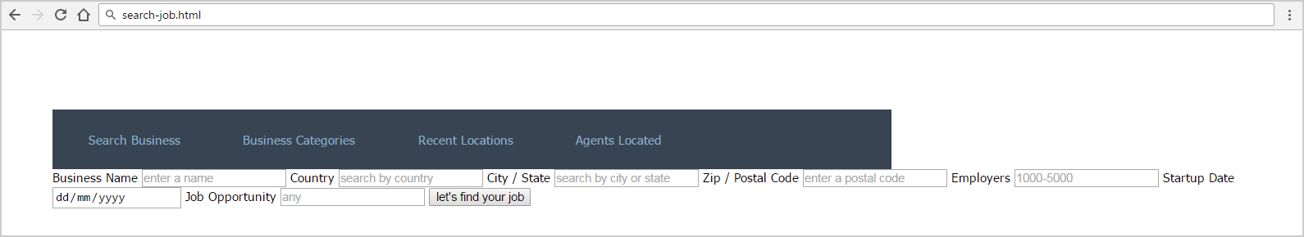

* li:first-child a::before
  + content: "\f002";
* li:nth-child(2) a::before
  + content: "\f02c";
* li:nth-child(3) a::before
  + content: "\f041";
* li:nth-child(4) a::before
  + content: '\f007';
* <li> hover
  + background-color: #3BBC96;
* <li> hover a
  + Text Color: #ffffff;

Test the site navigation in the browser:

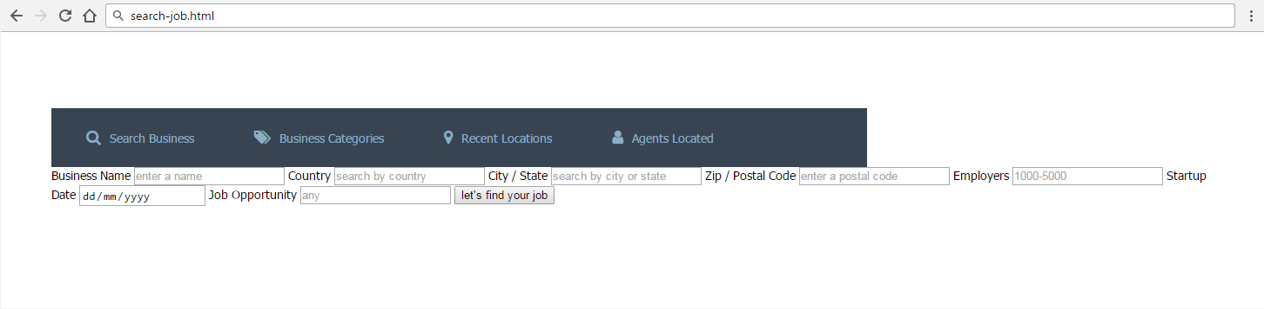

Style the Main content block:

* Make the background #EEEEEE
  + Use 70% width;
  + Display: flex;
  + Flex-Wrap: wrap;
* Label
  + Color: #374574;
  + Display: block;
  + Font Weight: bold;
  + Width: 210px;
  + Margin Left: 38px;
  + Margin Top: 20px;
* Input
  + Border: 1px solid #CDCDCD;
  + Margin Top: 20px;
  + Margin Bottom: 20px;
  + Height: 46px;
  + Padding Left: 14px;
* Button
  + Margin-left: 38px;
  + Width: 210px;
  + Height: 46px;
  + Text-transform: uppercase;
  + Background-color: #384452;
  + Color: #CED1CA;
* Button hover
  + Background-color: #3BBC96;
  + Color: #FFF7E4;
  + Cursor: pointer;

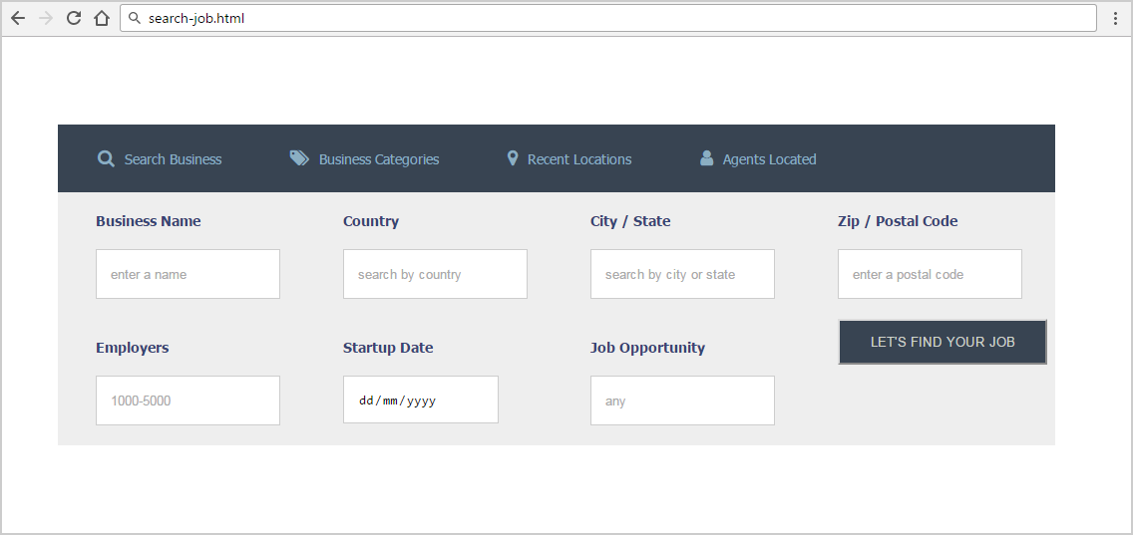

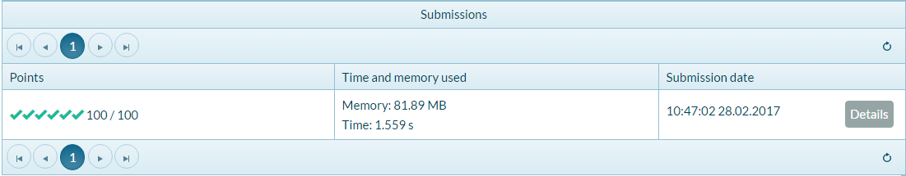

## Product Form

Create a Web page (HTML5 + CSS3 + images) that looks and behaves like the screenshots below:

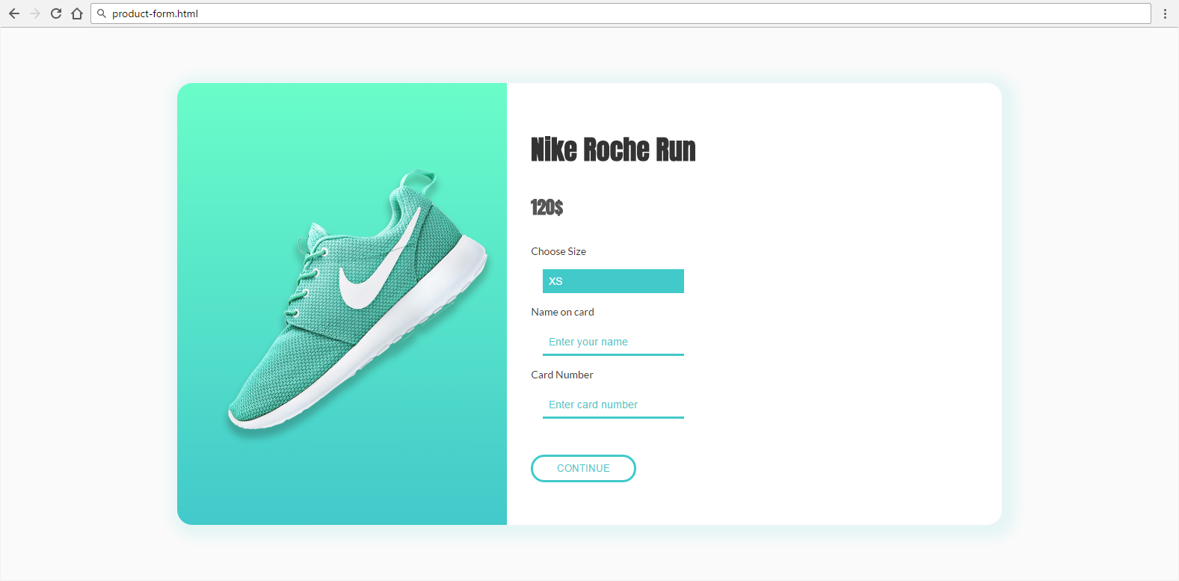

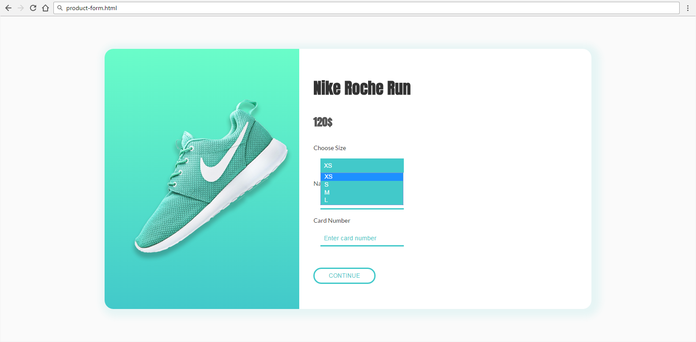

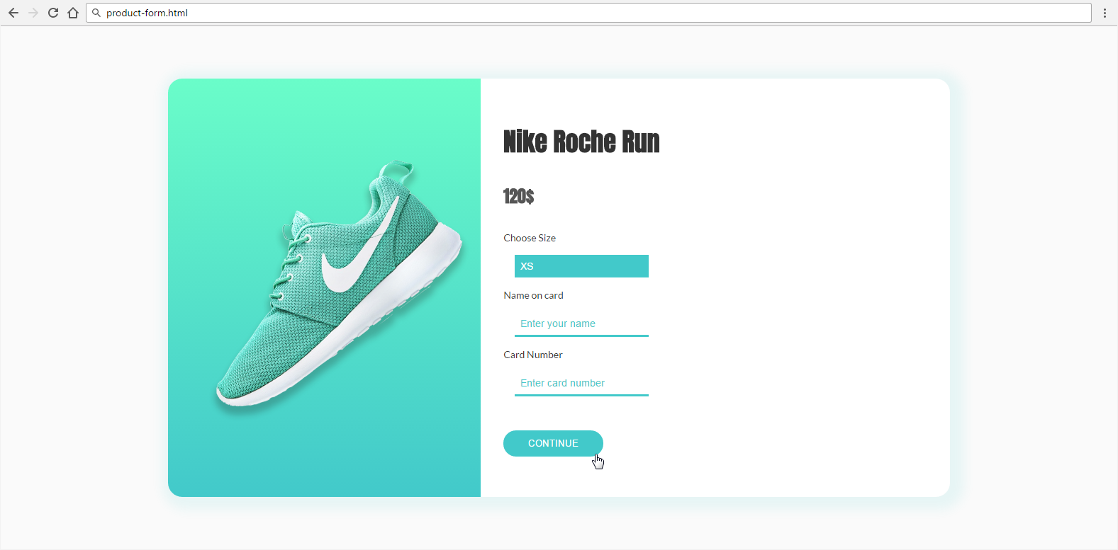

* The mouse cursors in the above screenshots explain what happens when the mouse moves over a project or a group.

### Input

You are given the above screenshots + all required images + the texts on the site.

### Output

The output should be valid HTML5 + CSS3 + images that implement the above Web page.

### Constraints

* Font: 14px 'Lato', sans-serif.
  + <https://fonts.googleapis.com/css?family=Lato:400,700>
  + <https://fonts.googleapis.com/css?family=Anton>
* Background gradient: linear-gradient(to bottom, #6afdc9 0%,#42c9ca 100%)
* Form validation is not required.
* Responsive design is not required.
* Pixel-perfect implementation is not required.
* Take the colors from the pictures with color picker.

## Room Reservation

Create a Web page (HTML5 + CSS3 + images) that looks and behaves like the screenshots below:

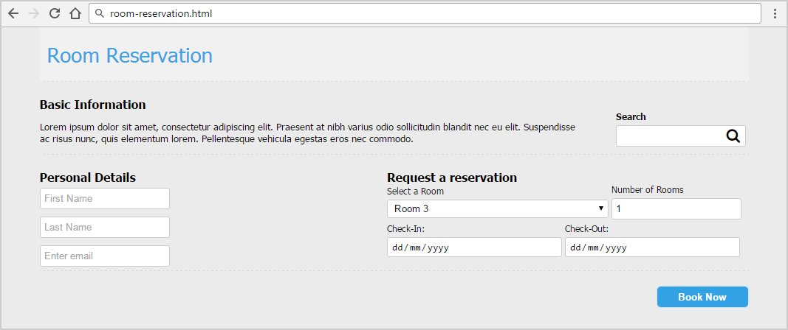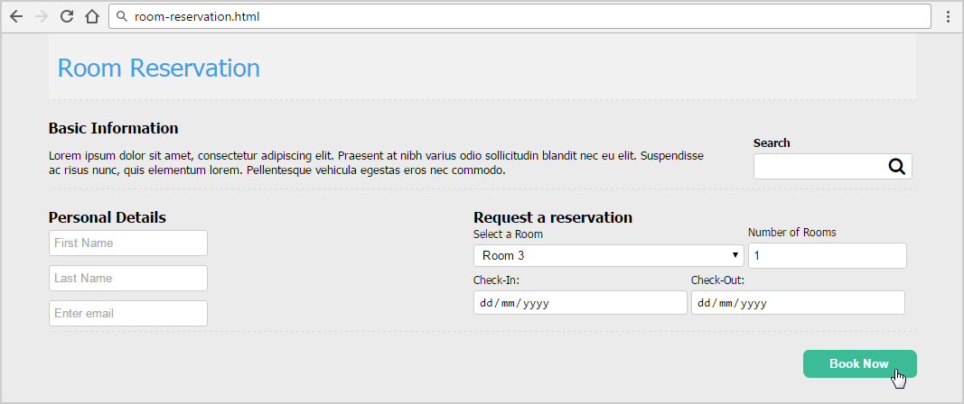

* The mouse cursors in the above screenshots explain what happens when the mouse moves over a project or a group and when the browser window resizes.

### Input

You are given the above screenshots + all required images + the texts on the site.

### Output

The output should be valid HTML5 + CSS3 + images that implement the above Web page.

### Constraints

* Font: 13px Tahoma, Helvetica, sans-serif.
* Title: 28px; Subtitle: 16px; Tahoma, Helvetica, sans-serif.
* “Select a room” is drop-down.
* “Number of rooms” is number field.
* “Check-in” and “Check-out” are date fields.
* Other fields are text.
* Form validation is not required.
* Responsive design is not required.
* Pixel-perfect implementation is not required.
* Take the colors from the pictures with color picker.

## Free Account

Create a Web page (HTML5 + CSS3 + images) that looks and behaves like the screenshots below:

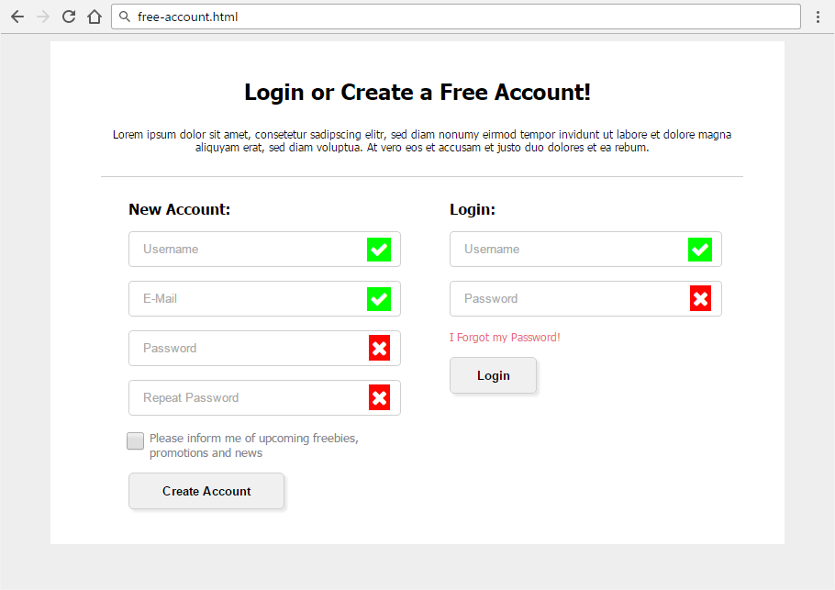

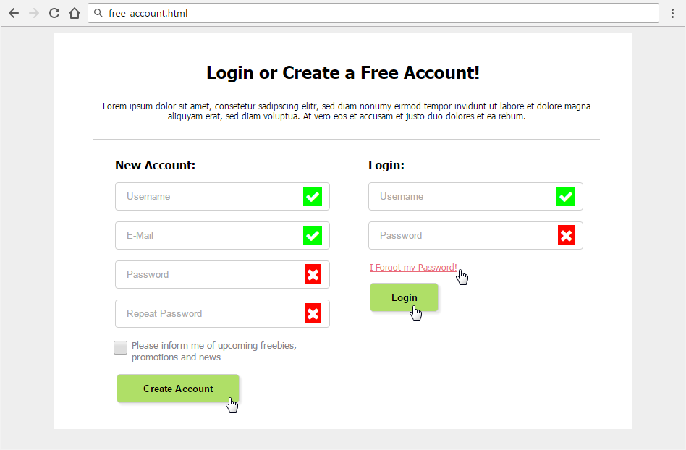

* The mouse hand-pointers and the bottom bar in the screenshots are not part of your page, so please skip them.

### Input

You are given the above screenshots and all required images.

### Output

The output should be valid HTML5 + CSS3 + images that implement the above Web form.

* You do not need to implement form validation.

### Constraints

* Font: Tahoma, Helvetica, sans-serif.
* Site content: fixed width 800px.
* Heading font-size: 24px.
* Form validation is not required.
* Responsive design is not required.
* Pixel-perfect implementation is not required.
* Icons from FontAwesome: content: '\f00c'; content: '\f00d'**;**
* Take the colors from the pictures with color picker.

## Edit User Form

Create a Web page (HTML5 + CSS3 + images) that looks and behaves like the screenshots below:

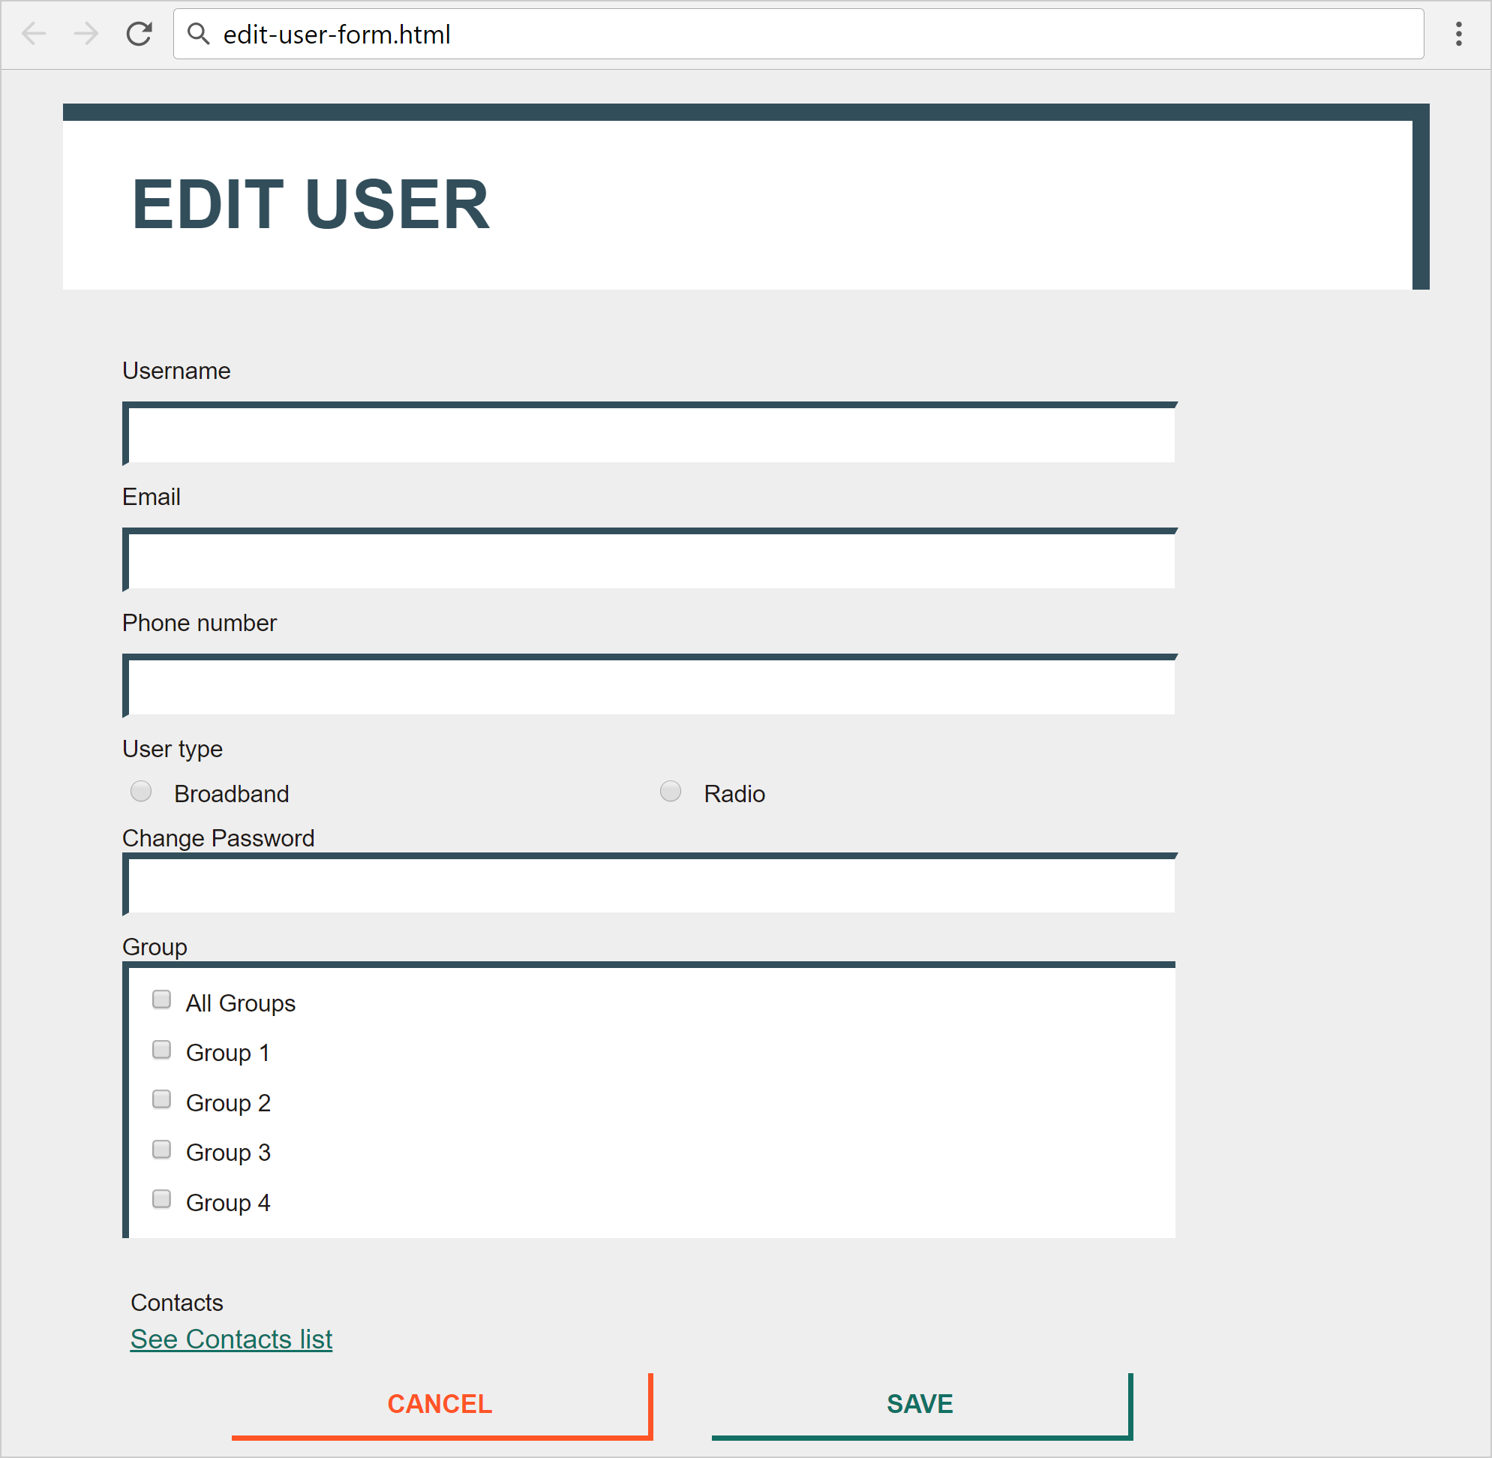

* The mouse hand-pointers and the bottom bar in the screenshots are not part of your page, so please skip them.

### Input

You are given the above screenshots + the images for the news items + the texts on the site.

### Output

The output should be valid HTML5 + CSS3 + images that implement the above Web page.

### Constraints

* Font: 16px "Roboto", Helvetica, sans-serif;
* <https://fonts.googleapis.com/css?family=Roboto:400,500,700>
* Default text: #1E1917;
* Title: 40px;
* Labels: 14px/500;
* Buttons font-size: 15px/700;
* Link: #136F63, 15px, no-hover effect
* Content max-width: 800px;
* Form validation is not required.
* Responsive design is not required.
* Pixel-perfect implementation is not required.